**CS 101 INTRODUCTION TO COMPUTING**

**SESSIONAL 2, FALL 2014**

**Date: 13th Nov, 2014 Marks: 30 Time: 90 minutes**

**IMPORTANT:** Solve the exam in the space provided. Write your name, roll number and section on every page. You can ask for extra sheets for rough work but any extra sheets ***WILL NOT*** be marked or collected

**Good luck!**

**QUESTION 1 (6 Marks)**

Given the definition of the functions below, write the values of the variables (a, b, c, d, and e) in the boxes provided AFTER a statement is executed.

|  |  |
| --- | --- |
| int GuessWhat(int &a,int &b)  {  int c = 0;  a = c + 1;  b = c + 2;  return a + b;  } | int GuessAgain(int &a,int &b,int c,int d)  {  int i;  c = c + 5;  d = d * 2;  for ( i = 0; i < c ; i++ )  {  a = a + d;  }  b = c + d;  return i;  } |

int main()

{

|  |  |  |  |  |  |
| --- | --- | --- | --- | --- | --- |
|  | **A** | **b** | **c** | **d** | **e** |
| int a=0, b=0, c=0, d=0, e=0; | **0** | **0** | **0** | **0** | **0** |
| e = GuessWhat(a,b); | **1** | **2** | **0** | **0** | **3** |
| e = GuessWhat(d,c); | **1** | **2** | **2** | **1** | **3** |
| e = GuessAgain(a,b,c,d); | **15** | **9** | **2** | **1** | **7** |
| e = GuessAgain(d,c,b,a); | **15** | **9** | **44** | **421** | **14** |
| return 0;  } | | | | | |

**QUESTION 2 (4 Marks)**

1. Hassan and Ahmad decide that they will go out that evening to the playground if it is dry. If it is raining, they will both go to Hassan’s house and play with Hassan’s model train set. However, they can play with model train only if Hassan’s father is at home to help them set it up; otherwise they will watch television. In the space below, write the ***prototype*** of a function which decides whether or not they will watch television given that all necessary information is passed to this function as parameters.

|  |
| --- |
| bool WillWatchTelevision( bool isDry, bool isFatherHome); |

1. Given the radius $r$ and the height $h$ of a cylinder, in the space below, write the prototype of a function which calculates its surface area $A$ and volume $V$ given the following formulas. The function should make both these values available to code which is calling the function.

$$A=2πrh+2πr^{2}$$

$$V=πr^{2}h$$

|  |
| --- |
| float CalculateSurfaceAreaAndVolume( float r, float h, float& area); // returns volume OR  float CalculateSurfaceAreaAndVolume( float r, float h, float& volume); // returns area  OR  void CalculateSurfaceAreaAndVolume( float r, float h, float& area, float &volume); |

**QUESTION 3 (10 Marks)**

Assume that you have been given the code of a function which takes the coordinates of a point on the screen as input, and returns whether or not there is an asterisk/star $(*)$ on that point. The prototype of the function is given below.

bool hasStar(int x, int y);

Write C++ code for a function called countStars which takes the top-left and bottom-right coordinates of a rectangle as input and returns the total number of stars in that rectangle. For example, in the screen below, for the inputs 2,2,4,3, the function should return 5.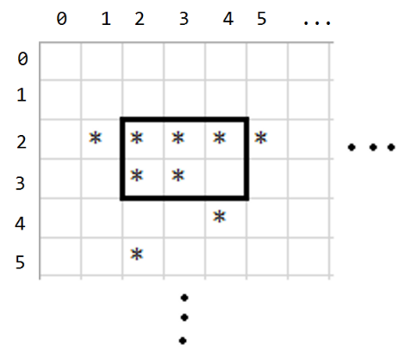

|  |
| --- |
| int countStars (int top, int left, int bottom, int right)  {  int sum = 0;  for (int x = left; x <= right; x++)  {  for (int y = top; y <= bottom; y++)  {  if (hasStar(x,y))  {  sum++;  }  }  }  return sum;  } |

**QUESTION 4 (10 Marks)**

You are given an integer array **arr** and its size **MAX_SIZE**. Write a program that takes in a range from the user and print the total number of elements that fall within the range.

Suppose the array **arr** contains: 200, 10, 334, 12, 145, 101, 88, 21, 44, 76. In this case **MAX_SIZE** = 10.

**Sample example 1:**

**Input**: 50 and 100

**Output**: 2 //88 and 76 fall within the range [50 - 100]

**Sample example 2:**

**Input**: 103 and 10

**Output**: 7 //10, 12, 101, 88, 21, 44, and 76 fall within the range [103 - 10]

|  |
| --- |
| #include <iostream>  using namespace std;  int main()  {  // Assume the code to declare and initialize the array is already given here  // from this point you have a declared and populated integer array by the name **arr** and  // its size is given to you in an integer **MAX_SIZE.**  // Write you code on the next page.  void swap(int &a, int &b)  {  int temp = a;  a = b;  b = temp;  }  int main()  {  int arr[] = {200, 10, 334, 12, 145, 101, 88, 21, 44, 76};  const int MAX_SIZE = 10;  int low, high;  cin >> low >> high;  if (low>high)  {  swap(low,high);  }  int count = 0;  for (int i = 0; i < MAX_SIZE; i++)  {  if (arr[i]>=low && arr[i]<=high)  {  count++;  }  }  cout << count <<endl;  return 0;  } |